A title on land taxes and house price capitalization

**Introduction**

* RQ: Does changes to house taxation capitalize into house prices?

In this paper I would investigate the link between land taxes and house prices. In 2007, the Danish “Strukturreform” merged 271 municipalities into 98. This reform specifically altered land taxes (“grundskyldspromille”) in many municipalities. Some were unchanged, but the vast majority of municipalities experienced a rise or fall. Plenty of exogenous variation. Specifically, I am interested whether this (potential) capitalization is stronger in quantiles of house prices.

* Motivation: The new property valuations from the Danish Ministry of Tax has been eagerly anticipated for some time with some houseowners more nervous than others. Will this have an effect on house prices? Let’s take a look at the last time we had proper exogenous variation in changes to housing taxation to determine whether this could potentially have any effect on house prices.
* Main inspiration: Schou et al (2018)

**Data**

* Webscraped from Boliga.dk’s API using python.
* State all sources:
  + Shapefiles: dataforsyningen.dk (municipalities and regions)
  + Regional house price index: dst.dk
  + Boliga.dk (prices + BBR)
  + Strukturreform: kl.dk (that weird PDF)…
* Map of exogenous variation to changes to land taxes (grundskyldspromille)
  + Do I leave out some municipalities and refer to them areas instead??
* Plot of average house prices, categorized between municipalities/areas with higher/lower taxes.
* Table an example(?)

**Econometric model**

* Main specification:

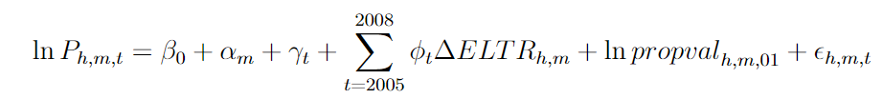

* ‘Expansion’:

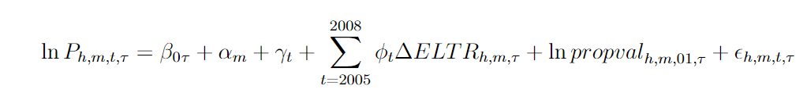

* **Very important:** I am assuming any fixed effect (municipal/area & time) affect house prices equally!!

**Results**

* Preliminary results show capitalization is higher for the most expensive houses (unsurprisingly)?
* Table with quantiles 0.1, 0.25, 0.5, 0.75 + OLS/FE results.

**Conclusion**

* Sum up key points and answer to RQ. Looks very much like the capitalization is higher for the most expensive (single-family) homes – as my results show.

**References**

* Sweden: <https://www.sciencedirect.com/science/article/pii/S0167268117302585>
  + Limited capitalization into house prices – only at the very top…
* Italy: <https://www.sciencedirect.com/science/article/pii/S0014292119301084>
  + Same municipal-level change to property taxes…
* US: <https://citeseerx.ist.psu.edu/document?repid=rep1&type=pdf&doi=cd0566bc047cb8e64d93893c79a7d2091580db7b>
  + Effect of proposed (!) tax reforms on metropolitan house prices